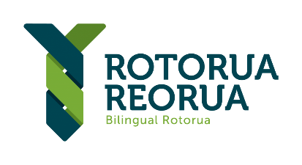



MATARIKI 2022

ROTORUA REORUA FUND
APPLICATION FORM

Please ensure you have read and fully understand the criteria before applying for the Matariki Rotorua Reorua Fund

Name of Rōpū
(org/group/collective/appllicant)
Date of application
Physical Address
Name of contact person
Email |  | Phone
Incorporated Society No |  | CC No
Name of Project

- Please tell us about your kaupapa / project?

- Please tell us about the make-up of your rōpū/organisation/group/collective. Please note, kaupapa supported by the Rotorua Reorua Matariki 2022 Fund must be Te Arawa led or Te Arawa co-led.

- How do you believe your kaupapa will help meet the Te Arawatanga whāinga of the Te Arawa 2050 Vision?

- How do you intend to ensure your kaupapa meets Rotorua Reorua Goals? Refer to the bilingual events checklist to help identify how you can incorporate reoruatanga into your kaupapa.

- Please explain how your proposed kaupapa Matariki meets the Values for Matariki Celebrations.

- What do you want to use the funds for and how much are you applying for? (Total fund available is $10,000. We expect average distributions to be between $500 - $2500)

- Please provide any other information that you think might be useful:

DECLARATION AND PRIVACY ACT 1993 AUTHORISATION
This authorisation relates to information in this application that the Te Tatau O Te Arawa (“Te Tatau”) may hold about you now or in the future:
- I have read and fully understand the funding criteria
- I/we hereby declare that the information supplied here about myself, or on behalf our organisation is correct
- I give permission to Te Tatau and Rotorua Lakes Council to make independent confidential enquiries relating to my application
- I agree to provide Te Tatau and Rotorua Lakes Council images and or videos of the event or project that receives funding.
- If successful, I authorise Te Tatau and Rotorua Lakes Council to use my name/photograph for promotional purposes
- I agree to participate in promotional work as may be reasonably required by Te Tatau and Rotorua Lakes Council, at no charge
- I accept that the decision of this fund is final and that no correspondence will be entered into
- I declare that the information I have provided is true and factual

Full Name of Applicant
Name of Bank
Branch
Account No

Due to the new money laundering law, we are required to call all those individuals receiving funding from Te Tatau for the first time to verify their bank account details.

Signature |  | Date

THANK YOU for your application.

Please do not attach any documents to this application form.

Please email this application form to reach the following address by 5 pm 06 May 2022:
Email: Jenny@tetatau.nz
Late applications will not be accepted. If you have any queries, please email: Jenny@tetatau.nz
Decision and notification will be completed by 6 May 2022

